Benchmarking:Myhal Centre for Engineering Innovation and Entrepreneurship

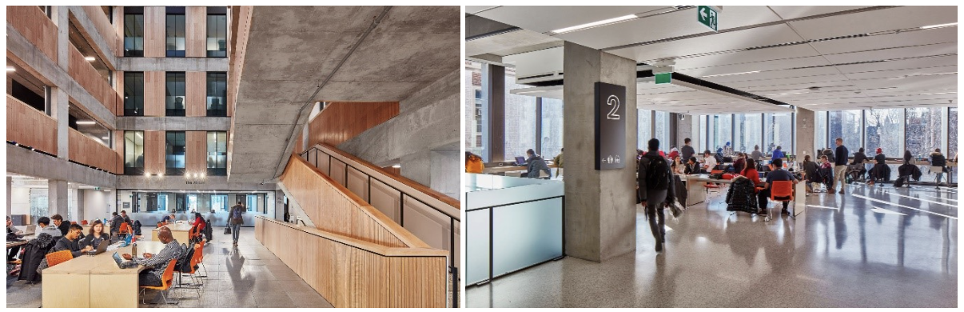

Figure 1. *Myhal Centre Collaborative Spaces(the fifth floor)*

The Myhal Centre is designed to enhance engineering education and research, fostering collaboration among students, researchers, and industry partners. The facility boasts state-of-the-art prototyping facilities, multidisciplinary research hubs, design studios, and technology-enhanced learning spaces. Its open and flexible spaces encourage interaction and innovation, setting a new standard for engineering education facilities.

**Table 1. *Myhal Centre Storage Observation.***

| **Figure(s)** | **Description** |
| --- | --- |
|  | * The integration of lockers into the wall structure represents an intelligent design solution that significantly enhances space efficiency within the corridor. * The extensive deployment of numerous lockers ensures ample personal storage capacity. |
|  | * These are examples of underutilization of space. Lots of clutter piled up on the floor, while there is still plenty of free space on the shelves and desks. |
|  | * The storage room pictured here has a number of display shelves, organizers and bookcases to categorize the large amount of clutter in the storage room. * In addition to traditional ways of organizing, there is a use of tool wall organizers to save ground space. |

**Table 2. *Pros and Cons of Myhal Centre Design***

| Pros | Cons |
| --- | --- |
| 1. Encourages collaboration through open spaces 2. Supports innovation with state-of-the-art facilities 3. Flexible design accommodates various activities 4. Multifunctional use for different areas | 1. High-tech features may increase operational costs 2. Open spaces might require more effective noise management strategies |

**Table 3. *Space Objective Assessment.***

| **Space Objectives** | Goals and Description |
| --- | --- |
| Maximize utilization of space: | The design optimizes space for a variety of uses, from individual study to large collaborative projects. |
| Maximize utilization of space: | The flexible layout can easily be adjusted to meet the evolving requirements of users and technological advancements. |

**Table 4. *Storage Objective Assessment.***

| **Storage Objectives** |  |
| --- | --- |
| **Innovative storage solutions:** | Utilizes smart storage solutions for equipment and materials, ensuring easy access without compromising space functionality |
|
|
|

The Myhal Centre for Engineering Innovation and Entrepreneurship represents a significant advancement in engineering education and collaborative research. By comparing it to other spaces like the Sussex Clubhouse, it's evident that the Myhal Centre's design prioritizes flexibility, innovation, and collaboration. Its state-of-the-art facilities and open spaces encourage interaction among students, researchers, and industry partners, setting a new benchmark for academic and research institutions. The Myhal Centre's approach to maximizing space utilization and fostering an environment conducive to innovation offers valuable insights for enhancing our design‘s multi functionality and user experience.